**TD Bank only bringing back 90 days on Bravo Report**

**Go to the TD Bank website on a desktop and log in. At the top go to the *My TD* dropdown and select *TD Alerts***

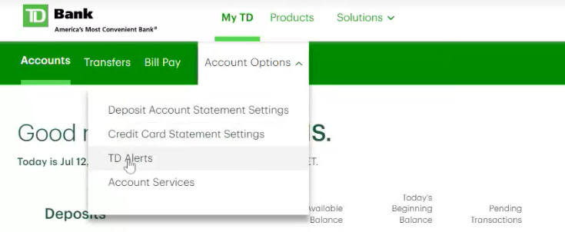

**Then scroll down to *Online Statements and Notices and click on the green link “turning off paper statements and notices”***

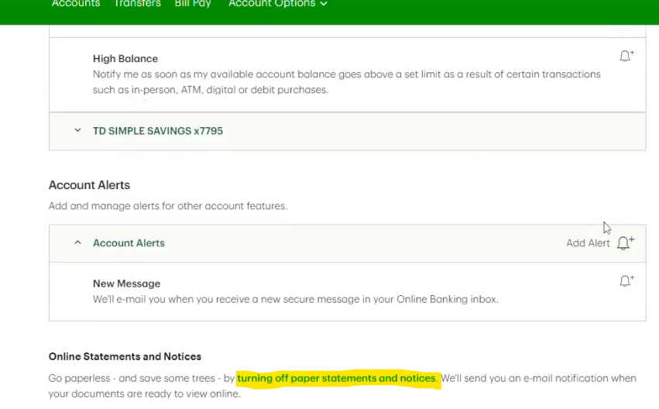

**Scroll down and find *Update Settings***

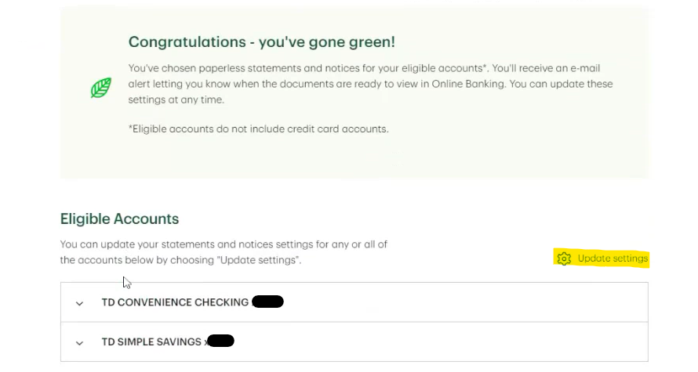

**Then check off each box for the accounts you need 120 days and select continue**

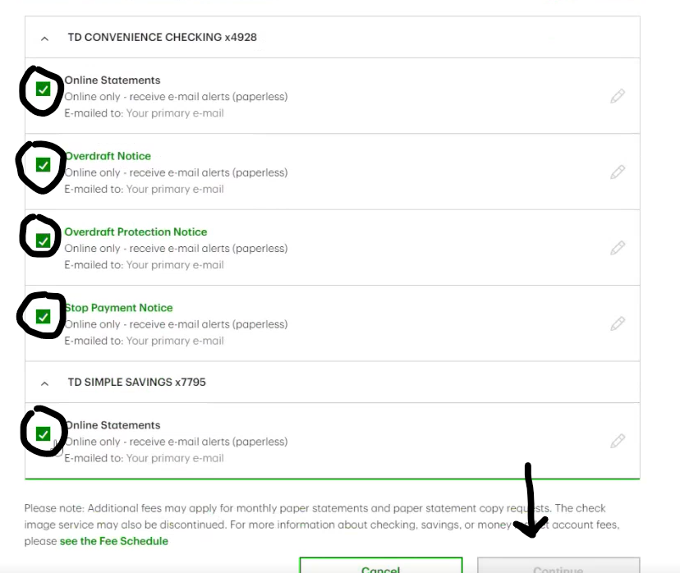

**Once this is saved, send the customer another Bravo report and have them complete the process again. This will enable 120 days of transactions to be brought back with the Baseline.**